# Graduate Rotational Internship Program

# Task # 6 – Cloud Computing

What is Cloud Computing:

Cloud computing is the on-demand availability of computer system resources, especially data storage and computing power, without direct active management by the user. The term is generally used to describe data centers available to many users over the Internet.

There are three types of Cloud Computing services:

Infrastructure as a Service (IaaS)

Platform as a Service (PaaS)

Software as a Service (SaaS)

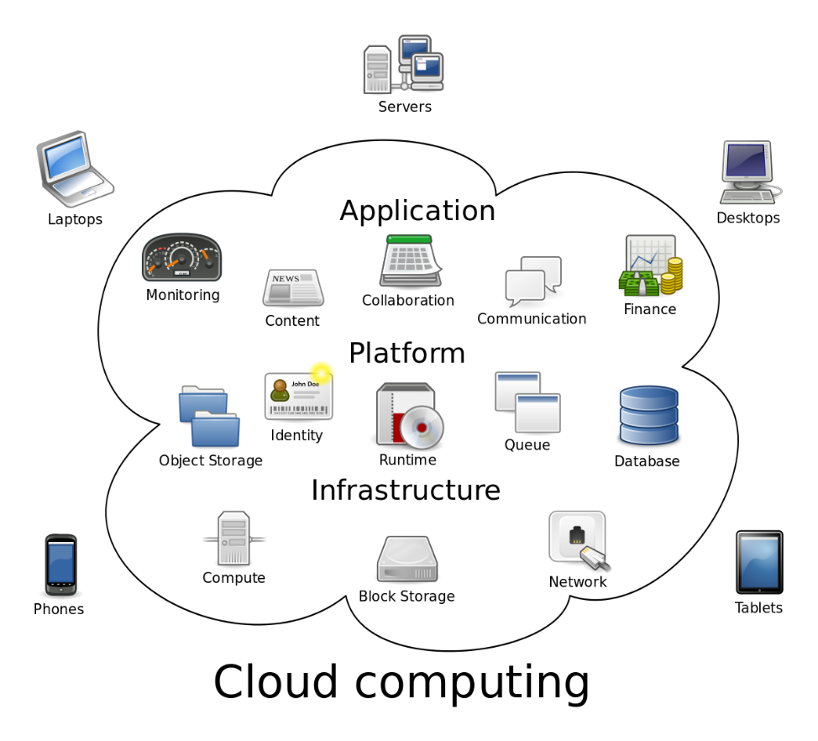

SaaS: Software as a Service

Software as a Service, also known as cloud application services, represents the most commonly utilized option for businesses in the [cloud market](https://www.bmc.com/blogs/cloud-revenue-market-share-trends/). SaaS utilizes the internet to deliver applications, which are managed by a third-party vendor, to its users. A majority of SaaS applications run directly through your web browser, which means they do not require any downloads or installations on the client side.

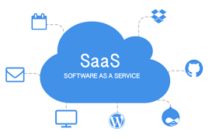

SaaS Delivery

Due to its web delivery model, SaaS eliminates the need to have IT staff download and install applications on each individual computer. With SaaS, vendors manage all potential technical issues, such as data, middleware, servers, and storage, resulting in streamlined maintenance and support for the business.

SaaS Advantages

SaaS provides numerous advantages to employees and companies by greatly reducing the time and money spent on tedious tasks such as installing, managing, and upgrading software. This frees up plenty of time for technical staff to spend on more pressing matters and issues within the organization.

SaaS Characteristics

There are a few ways to help you determine when SaaS is being utilized:

Managed from a central location

Hosted on a remote server

Accessible over the internet

Users not responsible for hardware or software updates

When to Use SaaS

SaaS may be the most beneficial option in several situations, including:

Startups or small companies that need to launch ecommerce quickly and don’t have time for server issues or software

Short-term projects that require quick, easy, and affordable collaboration

Applications that aren’t needed too often, such as tax software

Applications that need both web and mobile access

SaaS Limitations and Concerns

**Interoperability.**Integration with existing apps and services can be a major concern if the SaaS app is not designed to follow open standards for integration. In this case, organizations may need to design their own integration systems or reduce dependencies with SaaS services, which may not always be possible.

**Vendor lock-in.**Vendors may make it easy to join a service and difficult to get out of it. For instance, the data may not be portable–technically or cost-effectively–across SaaS apps from other vendors without incurring significant cost or inhouse engineering rework. Not every vendor follows standard APIs, protocols, and tools, yet the features could be necessary for certain business tasks.

**Lack of integration support.**Many organizations require deep integrations with on-premise apps, data, and services. The SaaS vendor may offer limited support in this regard, forcing organizations to invest internal resources in designing and managing integrations. The complexity of integrations can further limit how the SaaS app or other dependent services can be used.

**Data security.**Large volumes of data may have to be exchanged to the backend data centers of SaaS apps in order to perform the necessary software functionality. Transferring sensitive business information to public-cloud based SaaS service may result in compromised security and [compliance](https://www.bmc.com/blogs/it-security-vs-it-compliance-whats-the-difference/) in addition to significant cost for migrating large data workloads.

**Customization.**SaaS apps offer minimal customization capabilities. Since a one-size-fits-all solution does not exist, users may be limited to specific functionality, performance, and integrations as offered by the vendor. In contrast, on-premise solutions that come with several software development kits (SDKs) offer a high degree of customization options.

**Lack of control.**SaaS solutions involves handing control over to the third-party service provider. These controls are not limited to the software–in terms of the version, updates, or appearance–but also the data and governance. Customers may therefore need to redefine their data security and governance models to fit the features and functionality of the SaaS service.

**Feature limitations.**Since SaaS apps often come in a standardized form, the choice of features may be a compromising tradeoff against security, cost, performance, or other organizational policies. Furthermore, vendor lock-in, cost, or security concerns may mean it’s not viable to switch vendors or services to serve new feature requirements in the future.

**Performance and downtime.**Because the vendor controls and manages the SaaS service, your customers now depend on vendors to maintain the service’s security and performance. Planned and unplanned maintenance, cyber-attacks, or network issues may impact the performance of the SaaS app despite adequate service level agreement (SLA) protections in place.

Examples of SaaS

These are several popular examples of SaaS, including: Google GSuite (Apps), [Dropbox](https://www.dropbox.com/), [Salesforce](https://www.salesforce.com/), [Cisco WebEx](https://www.webex.com/), [SAP Concur](https://www.concur.com/), and [GoToMeeting](https://www.gotomeeting.com/).

PaaS: Platform as a Service

Cloud platform services, also known as Platform as a Service (PaaS), provide cloud components to certain software while being used mainly for applications. PaaS delivers a framework for developers that they can build upon and use to create customized applications. All servers, storage, and networking can be managed by the enterprise or a third-party provider while the developers can maintain management of the applications.

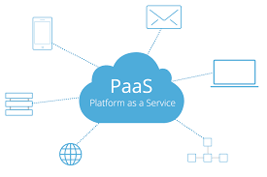

PaaS Delivery

The delivery model of PaaS is similar to SaaS, except instead of delivering the software over the internet, PaaS provides a platform for software creation. This platform is delivered via the web, giving developers the freedom to concentrate on building the software without having to worry about operating systems, software updates, storage, or infrastructure.

PaaS allows businesses to design and create applications that are built into the PaaS with special software components. These applications, sometimes called middleware, are scalable and highly available as they take on certain cloud characteristics.

PaaS Advantages

No matter the size of your company, using PaaS offers numerous advantages, including:

Simple, cost-effective development and deployment of apps

Scalable

Highly available

Developers can customize apps without the headache of maintaining the software

Significant reduction in the amount of coding needed

Automation of business policy

Easy migration to the hybrid model

PaaS Characteristics

PaaS has many characteristics that define it as a cloud service, including:

Builds on virtualization technology, so resources can easily be scaled up or down as your business changes

Provides a variety of services to assist with the development, testing, and deployment of apps

Accessible to numerous users via the same development application

Integrates web services and databases

When to Use PaaS

Utilizing PaaS is beneficial, sometimes even necessary, in several situations. For example, PaaS can streamline workflows when multiple developers are working on the same development project. If other vendors must be included, PaaS can provide great speed and flexibility to the entire process. PaaS is particularly beneficial if you need to create customized applications. This cloud service also can greatly reduce costs and it can simplify some challenges that come up if you are rapidly developing or deploying an app.

PaaS Limitations and Concerns

**Data security.**Organizations can run their own apps and services using PaaS solutions, but the data residing in third-party, vendor-controlled cloud servers poses security risks and concerns. Your security options may be limited as customers may not be able to deploy services with specific hosting policies.

**Integrations.**The complexity of connecting the data stored within an onsite data center or off-premise cloud is increased, which may affect which apps and services can be adopted with the PaaS offering. Particularly when not every component of a legacy IT system is built for the cloud, integration with existing services and infrastructure may be a challenge.

**Vendor lock-in.**Business and technical requirements that drive decisions for a specific PaaS solution may not apply in the future. If the vendor has not provisioned convenient migration policies, switching to alternative PaaS options may not be possible without affecting the business.

**Customization of legacy systems.**PaaS may not be a plug-and-play solution for existing legacy apps and services. Instead, several customizations and configuration changes may be necessary for legacy systems to work with the PaaS service. The resulting customization can result in a complex IT system that may limit the value of the PaaS investment altogether.

**Runtime issues.**In addition to limitations associated with specific apps and services, PaaS solutions may not be optimized for the language and frameworks of your choice. Specific framework versions may not be available or perform optimally with the PaaS service. Customers may not be able to develop custom dependencies with the platform.

**Operational limitation.**Customized cloud operations with management automation workflows may not apply to PaaS solutions, as the platform tends to limit operational capabilities for end users. Although this is intended to reduce the operational burden on end users, the loss of operational control may affect how PaaS solutions are managed, provisioned, and operated

Examples of PaaS

Popular examples of PaaS include [AWS Elastic Beanstalk](https://aws.amazon.com/elasticbeanstalk/), [Windows Azure](https://azure.microsoft.com/en-us/free/windows-server-on-azure/), [Heroku](https://www.heroku.com/), [Force.com](https://developer.salesforce.com/platform/force.com), [Google App Engine](https://cloud.google.com/appengine/), and [OpenShift](https://www.openshift.com/).

IaaS: Infrastructure as a Service

Cloud infrastructure services, known as Infrastructure as a Service (IaaS), are made of highly scalable and automated compute resources. IaaS is fully self-service for accessing and monitoring computers, networking, storage, and other services. IaaS allows businesses to purchase resources on-demand and as-needed instead of having to buy hardware outright.

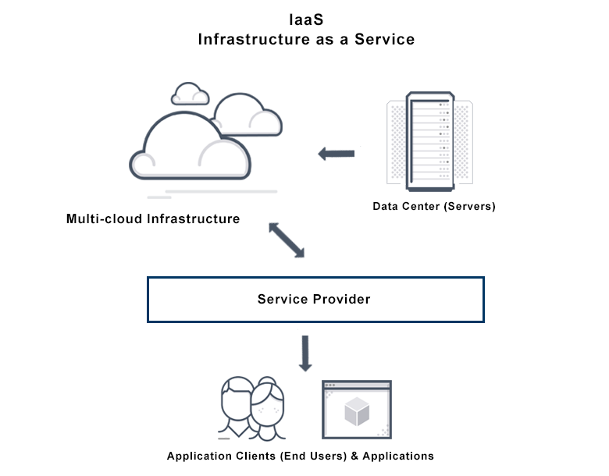

IaaS Delivery

IaaS delivers cloud computing infrastructure, including servers, network, operating systems, and storage, through virtualization technology. These cloud servers are typically provided to the organization through a dashboard or an API, giving IaaS clients complete control over the entire infrastructure. IaaS provides the same technologies and capabilities as a traditional data center without having to physically maintain or manage all of it. IaaS clients can still access their servers and storage directly, but it is all outsourced through a “virtual data center” in the cloud.

As opposed to SaaS or PaaS, IaaS clients are responsible for managing aspects such as applications, runtime, OSes, middleware, and data. However, providers of the IaaS manage the servers, hard drives, networking, virtualization, and storage. Some providers even offer more services beyond the virtualization layer, such as databases or message queuing.

IaaS Advantages

IaaS offers many advantages, including:

The most flexible cloud computing model

Easy to automate deployment of storage, networking, servers, and processing power

Hardware purchases can be based on consumption

Clients retain complete control of their infrastructure

Resources can be purchased as-needed

Highly scalable

IaaS Characteristics

Characteristics that define IaaS include:

Resources are available as a service

Cost varies depending on consumption

Services are highly scalable

Multiple users on a single piece of hardware

Organization retain complete control of the infrastructure

Dynamic and flexible

When to Use IaaS

Just as with SaaS and PaaS, there are specific situations when IaaS is most advantageous.

Startups and small companies may prefer IaaS to avoid spending time and money on purchasing and creating hardware and software. Larger companies may prefer to retain complete control over their applications and infrastructure, but they want to purchase only what they actually consume or need. Companies experiencing rapid growth like the scalability of IaaS, and they can change out specific hardware and software easily as their needs evolve. Anytime you are unsure of a new application’s demands, IaaS offers plenty of flexibility and scalability.

IaaS Limitations and Concerns

Many limitations associated with SaaS and PaaS models – such as data security, cost overruns, vendor lock-in and customization issues – also apply to the IaaS model. Particular limitations to IaaS include:

**Security.**While the customer is in control of the apps, data, middleware, and the OS platform, security threats can still be sourced from the host or other virtual machines (VMs). Insider threat or system vulnerabilities may expose data communication between the host infrastructure and VMs to unauthorized entities.

**Legacy systems operating in the cloud.**While customers can run legacy apps in the cloud, the infrastructure may not be designed to deliver specific controls to secure the legacy apps. Minor enhancement to legacy apps may be required before migrating them to the cloud, possibly leading to new security issues unless adequately tested for security and performance in the IaaS systems.

**Internal resources and training.**Additional resources and training may be required for the workforce to learn how to effectively manage the infrastructure. Customers will be responsible for data security, backup, and business continuity. Due to inadequate control into the infrastructure however, monitoring and management of the resources may be difficult without adequate training and resources available inhouse.

**Multi-tenant security.**Since the hardware resources are dynamically allocated across users as made available, the vendor is required to ensure that other customers cannot access data deposited to storage assets by previous customers. Similarly, customers must rely on the vendor to ensure that VMs are adequately isolated within the [multitenant cloud architecture](https://www.bmc.com/blogs/single-tenant-vs-multi-tenant/).

Examples of IaaS

Popular examples of IaaS include [DigitalOcean](https://www.digitalocean.com/" \t "_blank), [Linode](https://www.linode.com/" \t "_blank), [Rackspace](https://www.rackspace.com/), [Amazon Web Services (AWS)](https://aws.amazon.com/), [Cisco Metacloud](https://www.cisco.com/c/en/us/products/cloud-systems-management/metacloud/index.html), [Microsoft Azure](https://azure.microsoft.com/en-us/), and [Google Compute Engine (GCE)](https://cloud.google.com/compute/).

**Amazon Web Services (AWS)**

Founded in 2006, Amazon web services is the most comprehensive cloud service provider with an extensive range of products and services. AWS has an offering for everyone, starting from individuals to small organizations to the largest enterprises. This makes AWS an undisputed leader in the cloud market. AWS included all the latest technological innovations such as IoT, AI, Blockchain, machine learning, AR and VR in their service. AWS offers a wide range of IaaS and PaaS services which includes Elastic Cloud Compute (EC2), Elastic Beanstalk, Simple Storage Service (S3) and Relational Database Service (RDS).

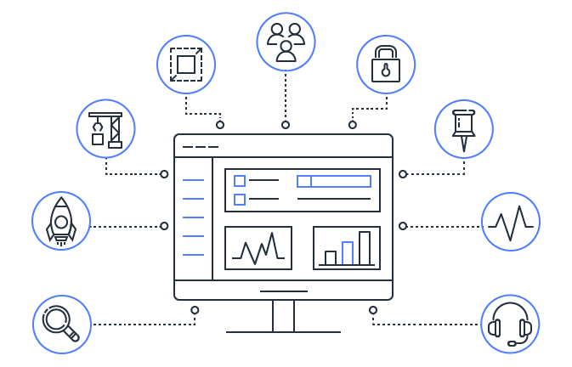

**Microsoft Azure**

Microsoft fairly earns the second position in the world’s top cloud service providers. It has built its hybrid platform ‘Azure’, including all the three major categories: SaaS, PaaS and IaaS, in order to meet complex business challenges in multiple industries (financial, retail, manufacturing, healthcare, gaming, government, etc.). Azure also includes IoT, AI and Blockchain in its solutions and also allows organizations to create applications ensuring high data security. As physical servers are not required, this reduces huge costs, such as an on-site server support team. The Azure Migration Center performs cloud transfers quicker and easier. The solution is also compatible with Linux. Microsoft Azure partnerships with other vendors such as Adobe, SAP, Cisco, etc., for ensuring more integration opportunities to the users.

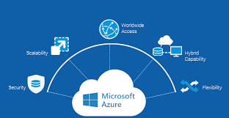

**Comparative Study: AWS vs Azure**

Let’s have a detailed comparative study between AWS and Azure based on various services they offer:

**1. Virtual Server**

A virtual server is a server that shares hardware and software resources with other operating systems (OS), versus dedicated servers. Virtual servers allow users to deploy, manage, and maintain OS and server software. Instance types provide combinations of CPU/RAM. Users pay for what they use with the flexibility to change sizes. These highly efficient virtual servers are popular in web hosting and cloud computing systems.

Amazon Elastic Compute Cloud ([Amazon EC2](https://aws.amazon.com/ec2/)) which is Amazon’s virtual server, is a web service that offers a secure and scalable computing capacity in the cloud. It is designed to make web-scale cloud computing accessible for developers. EC2 provides complete control of computing resources and allows you to run on Amazon’s highly efficient computing environment. It also decreases the time required to obtain and boot new server instances, enabling quick scale up or down your capacity depending on computing requirements. You have to pay for only the capacity you actually use.

On the other hand, Azure’s virtual server ‘[Azure Virtual Machines](https://azure.microsoft.com/en-in/services/virtual-machines/)’ provides the flexibility of virtualization without owning or maintaining the hardware that runs it. By supporting Linux, Windows Server, SQL Server, Oracle, IBM and SAP, Azure Virtual Machines provides virtualization for a broad spectrum of computing solutions including development and testing, running applications and extending data center. It offers the option of open-source software configured the way you need. Based on pay for what you use model, Azure Virtual Machines are highly secured and effectively meets compliance goals.

**2. Container Instances**

Container instances are a recent option to run containers without managing servers. Container instances bring two out of three core elements of serverless, which are the micro-billing model and an invisible structure. They have the ease-of-use of serverless and the availability and portability of containers. A container instance is a container deployed on a cloud platform, that can scale up and down as required, and discards the user of the responsibility of managing and maintaining it.

AWS provides Amazon Elastic Container Service ([Amazon ECS](https://aws.amazon.com/ecs/)) which is a highly scalable and efficient container orchestration service that supports Docker containers and allows to smoothly run and scale containerized applications on AWS. Amazon ECS eliminates the need of installation and operation of own container orchestration software, manage and scale a cluster of virtual machines, or schedule containers on those virtual machines. Simple API calls helps in the launch of Docker-enabled applications, the entire state of application queries, access of features such as IAM roles, security groups, load balancers, Amazon CloudWatch Events, AWS CloudFormation templates, and AWS CloudTrail logs etc.

Similarly Microsoft Azure allows by running workloads in the Azure Container Instances ([ACI](https://azure.microsoft.com/en-in/services/container-instances/)) so that you can focus on designing and developing your business applications rather than managing the infrastructure that runs them. Agility with the containers can be increased on demand by deploying containers to the cloud with exceptional simplicity and speed using a single command. The applications are highly secured as ACI provides hypervisor isolation for each of the container group to ensure containers run in isolation.

**3. Microservices / Container Orchestration**

Applications are basically built up of independently containerized components (called microservices) which are organised at the networking level in order to make the application run as expected. This process is called Container orchestration.

Amazon ECS helps you run microservices applications with native integration to AWS services and facilitates continuous integration and continuous deployment (CICD) pipelines. AWS offers a secure place to store and manage container images, orchestration that manages when and where your containers run, and flexible compute engines to power containers. [Elastic Container Service for Kubernetes](https://aws.amazon.com/eks/) (EKS) helps deploy orchestrated containerized applications with Kubernetes. It offers simplify monitoring and cluster management through auto upgrades and a built-in operations console.

From Microsoft, Azure Container Instances facilitates a layered approach to orchestration, giving all of the scheduling and management capabilities needed to run a single container, while allowing orchestrator platforms to manage multi-container tasks on top of it. As the underlying infrastructure for container instances is being managed by Azure, an orchestrator platform does not require to concern itself with finding an appropriate host machine on which to run a single container. Azure provides microservices architecture on [Azure Kubernetes Service (AKS)](https://azure.microsoft.com/services/kubernetes-service/) and [Azure Service Fabric](https://azure.microsoft.com/en-in/services/service-fabric/) for always-on, scalable, distributed apps.

**4. Serverless**

Serverless computing is a misnomer referring to a cloud-computing execution model in which the cloud provider runs the server, and dynamically manages the allocation of machine resources.

[AWS Lambda](https://aws.amazon.com/lambda/) is Amazon’s serverless code execution platform built on the concept of containerization. AWS Lambda uses the AWS Machine architecture to reduce the scope of containerization, allowing spin up and tear down individual pieces of functionality in the application. Functions run on Amazon Machine Instances, which are immutable web server objects that can be instantiated quickly in response to dynamic API requests. By using various AWS services and functionalities, an entire application can be built without having a true “server-side” set of code to manage.

Whereas Microsoft is a new entrant in the serverless realm. While Azure has significant PaaS functionalities for several years, they entered to the serverless app environment with Microsoft [Azure Functions](https://azure.microsoft.com/en-in/services/functions/) in the year 2016 only. The addition of Microsoft Azure Functions expanded the Azure platform with the ability to run arbitrary code in temporary execution environments.

**5. Integration Service and API Management**

Cloud integration service ( Messaging, Eventing, API )lets your organization create integrations between cloud application, but also between cloud and on-premise applications, data and processes across your enterprise. One can create connections to well known and less known SaaS applications using a bunch of cloud adapters, publish or subscribe to the Messaging Cloud Service, or use industry standards like SOAP & REST APIs.

Amazon offers various integration services through [AWS Application Integration](https://aws.amazon.com/products/application-integration/) suite comprising [Amazon SNS](https://aws.amazon.com/sns/) (fully managed pub/sub messaging), [Amazon SQS](https://aws.amazon.com/sqs/) (fully managed message queues), [Amazon MQ](https://aws.amazon.com/amazon-mq/) (managed message broker service for Apache ActiveMQ), [GraphQL Serverless API management](https://serverless.com/blog/running-scalable-reliable-graphql-endpoint-with-serverless/) using [AWS AppSync](https://aws.amazon.com/appsync/) (create a flexible API to securely access, manipulate, and combine data from one or more data sources), [API Gateway](https://aws.amazon.com/api-gateway/) (create, maintain, and secure APIs at any scale) and [GraphQL](https://aws.amazon.com/graphql/) (query and manipulate your data easily), [AWS Step Functions](https://aws.amazon.com/step-functions/) (build distributed applications using visual workflows), etc. for to integrate microservices, distributed systems, and serverless applications.

Azure on the other hand offers [Service Bus](https://azure.microsoft.com/en-in/services/service-bus/) (cloud messaging as a service (MaaS) and simple hybrid integration), [Azure Queue Storage](https://azure.microsoft.com/en-us/services/storage/queues/) (durable queues for large-volume cloud services), [Event Grid](https://azure.microsoft.com/en-in/services/event-grid/) (build reactive, event-driven apps with a fully managed event routing service), [API Managment](https://azure.microsoft.com/en-in/services/api-management/) (publish, manage, secure and analyse your APIs in minutes) and [Logic Apps](https://azure.microsoft.com/en-in/services/logic-apps/) (build powerful integration solutions without writing codes using visual workflows).

**6. Batch Computing**

Batch computing is used for frequently used programs that are executed with the least human interaction.

[AWS Batch](https://aws.amazon.com/batch/) enables developers to run hundreds of thousands of batch computing jobs on AWS easily and efficiently. AWS Batch offers the optimal quantity and type of computing resources such as CPU or memory optimized instances based on the volume and specific resource requirements of the batch jobs submitted. With AWS Batch, there is no need to install and manage batch computing software or server clusters that are required to run jobs, allowing organizations to focus on solving problems and analyzing results. AWS Batch plans, schedules, and executes batch computing workloads across the full range of AWS compute services and features, such as Amazon EC2 and Spot Instances.

On the other hand, [Azure Batch](https://azure.microsoft.com/en-in/services/batch/) is being used to run large-scale parallel and high-performance computing batch jobs efficiently in the Azure platform. Azure Batch builds and manages a pool of compute nodes (virtual machines), installs the applications you want to run, and schedules jobs to run on the nodes. There is no cluster or job scheduler software to install, manage, or scale. Instead, you use Batch APIs and tools, command-line scripts, or the Azure portal to configure, manage, and monitor your jobs.

**7. Object Storage**

Object storage, also known as object-based storage, is an approach to addressing and managing data storage as discrete units, called objects. Objects are kept inside a single container and are not stay as files inside a folder inside other folders. In a nutshell, object storage helps to understand file storage and block storage which are two common data storage methods.

AWS offers Amazon Simple Storage Service ([Amazon S3](https://aws.amazon.com/s3/)), which is an object storage service that offers top-notch scalability, data availability, security, and performance. Organizations of all sizes and industries can use it to store and protect any volume of data for a range of use cases, such as websites, mobile applications, backup and restore, archive, enterprise applications, IoT devices, and big data analytics. Amazon S3 provides user-friendly features for organizations to organize their data and configure access controls to meet specific business and compliance requirements.

Microsoft Azure offers [Azure Blob storage](https://azure.microsoft.com/en-in/services/storage/blobs/), which is an object storage solution for the cloud. Azure Blob storage is optimized for storing a massive volume of unstructured data such as text or binary data. Blob storage extends features such as strong consistency, object mutability, multiple blob types, and easy-to-use geo-redundancy.

Users or client applications can access objects in Blob storage via HTTP/HTTPS, from anywhere.

**8. Relational Database**

Azure: SQL Database, Database for MySQL, Database for PostgreSQL

AWS: RDS, Aurora

Any software applications require a database to store information. Azure and AWS both offer database services, regardless of whether you need a relational database or a NoSQL offering. Amazon’s [RDS](https://aws.amazon.com/rds/) (Relational Database Service ) and Microsoft’s equivalent SQL Server database both are highly available and enduring. RDS is an umbrella term and it includes Amazon Aurora, MySQL, MariaDB, Oracle, Microsoft SQL Server, and PostgreSQL. Aurora is a distinct offering because it is a high-end service dedicated to MySQL and PostgreSQL. Since Azure also offers those distinct services it made sense to break Aurora out from RDS.

**9. NoSQL Document Storage, GraphDB and in-memory data store**

AWS: DynamoDB, Amazon DocumentDB(MongoDB-compatible), Amazon Neptune, Amazon ElastiCache

Azure: Cosmos DB, Azure Cache for Redis

[Amazon DynamoDB](https://aws.amazon.com/dynamodb/) is a NoSQL database that supports key-value and document data models and allows developers to build modern, serverless applications that can start scale globally to support petabytes of data and tens of millions of read and write requests per second. DynamoDB is designed to run high-efficient and scalable applications that would overburden traditional relational databases. Amazon offers [Neptune](https://aws.amazon.com/neptune/), is a fast, reliable, fully managed graph database service that makes it easy to build and run applications that work with highly connected datasets. [Amazon ElastiCache](https://aws.amazon.com/elasticache/) is a fully managed [Redis](https://aws.amazon.com/redis/) and [Memcached](https://aws.amazon.com/memcached/) to seamlessly deploy, run, and scale popular open source compatible in-memory data stores.

[Azure Cosmos DB](https://azure.microsoft.com/en-in/services/cosmos-db/) is Microsoft’s proprietary globally-distributed, multi-model database service “for managing data at planet-scale” launched in May 2017. It is schema-agnostic, horizontally scalable and generally classified as a NoSQL database. Cosmos DB allows you to use key-value, graph, and document data in one service, at global scale and without worrying about schema or index management. Cosmos DB allows you to use your favorite API including [SQL (Document DB), JavaScript](https://docs.microsoft.com/en-us/azure/documentdb/documentdb-introduction), [Gremlin](https://docs.microsoft.com/en-us/azure/cosmos-db/graph-introduction), [MongoDB](https://docs.microsoft.com/en-us/azure/documentdb/documentdb-protocol-mongodb), and [Azure Table storage](https://docs.microsoft.com/en-us/azure/cosmos-db/table-introduction) to query your data. Azure Cosmos DB offers turnkey global distribution across any number of Azure regions by transparently scaling and replicating your data wherever your users are. Elastically scale your writes and reads all around the globe, and pay only for what you need. It offers multiple well-defined consistency models, guarantees single-digit-millisecond read and write latencies at the 99th percentile, and guarantees 99.999 high availability with multi-homing anywhere in the world — all backed by industry-leading, comprehensive service level agreements (SLAs). For in-memory data store, Azure provides a fully managed [Azure Cache for Redis](https://azure.microsoft.com/en-us/services/cache/) to power fast, scalable applications.

**10. Content Delivery Network**

A content delivery network (CDN) refers to a geographically distributed group of servers which work together to provide fast delivery of Internet content.

[Amazon CloudFront](https://aws.amazon.com/cloudfront/) is AWS’s content delivery network (CDN) service that securely delivers data, videos, applications, and APIs to customers globally with low latency, high transfer speeds, all within a developer-friendly environment. CloudFront is integrated with AWS — both physical locations that are directly connected to the AWS global infrastructure, as well as other AWS services. CloudFront works seamlessly with services including AWS Shield for DDoS mitigation, Amazon S3, Elastic Load Balancing or Amazon EC2 as origins for your applications, and Lambda@Edge to run custom code closer to customers’ users and to customize the user experience.

[Azure Content Delivery Network](https://azure.microsoft.com/en-in/services/cdn/) (CDN) reduces load times, save bandwidth, and speed responsiveness — whether developing or managing websites or mobile apps, or encoding and distributing streaming media, gaming software, firmware updates, or IoT endpoints.

**11. Data Analytics**

AWS provides one of the largest and most cost-effective sets of analytic services that run on the [data lake](https://aws.amazon.com/big-data/datalakes-and-analytics/what-is-a-data-lake/). Each analytic service is purpose-built for a wide range of analytics use cases such as interactive analysis ([Amazon Athena](https://aws.amazon.com/athena/)), big data processing ([Amazon EMR](https://aws.amazon.com/emr/)), data warehousing ([Amazon Redshift](https://aws.amazon.com/redshift/)), real-time analytics ([Amazon Kinesis](https://aws.amazon.com/kinesis/)), operational analytics ([Amazon Elasticsearch Service](https://aws.amazon.com/elasticsearch-service/)), dashboards and visualizations ([Amazon QuickSight](https://aws.amazon.com/quicksight/)), search solution for your website or application ([Amazon CloudSearch](https://aws.amazon.com/cloudsearch/)), etc.

Azure also offers a complete set of big-data solutions which help you gather, store, process, analyse and visualise data of any variety, volume or velocity, so you can explore new opportunities and take quick action. Few of Azure’s analytics offerings are [Azure Databricks](https://azure.microsoft.com/en-in/services/databricks/) (Apache® Spark™ based analytics platform), [HDInsight](https://azure.microsoft.com/en-in/services/hdinsight/) (Cloud Hadoop, Spark and Kafka service), [Azure Stream Analytics](https://azure.microsoft.com/en-in/services/stream-analytics/) (real-time data stream processing), [Data Lake Analytics](https://azure.microsoft.com/en-in/services/data-lake-analytics/) (on-demand pay-per-job analytics service with enterprise-grade security, auditing and support), [Azure Analysis Services](https://azure.microsoft.com/en-in/services/analysis-services/) (analytics engine as a service), [Power BI](https://powerbi.microsoft.com/en-us/) (build visualizations, perform ad hoc analysis, and develop business insights from data), [Azure Search](https://azure.microsoft.com/en-us/services/search/) (delivers full-text search and related search analytics and capabilities), etc.

**12. Streaming Data**

AWS’s [Amazon Kinesis](https://aws.amazon.com/kinesis/) helps to collect, process, and analyze real-time streaming data to get useful insights and respond quickly to new information. Amazon Kinesis cost-effectively process streaming data at any scale, along with the flexibility to choose the tools that best fit the requirements of your application. With Amazon Kinesis, real-time data such as video, audio, application logs, website clickstreams, and IoT telemetry data for machine learning, analytics, and other applications can be processed.

[Azure Stream Analytics](https://azure.microsoft.com/en-in/services/stream-analytics/) is an event-processing engine that allows you to examine high volumes of data streaming from various devices. Inbound data can be from various devices, sensors, web sites, social media channels, applications, and much more. It also supports extracting information from multiple data streams, identifying patterns, and relationships. Azure also offers [HDInsight](https://azure.microsoft.com/en-in/services/hdinsight/)— Easy, cost-effective, enterprise-grade service for open source analytics using Cloud Hadoop, Spark and Kafka service.

**13. Elastic Data Warehouse**

Elastic data warehouse means a fully managed data warehouse that analyzes data using business intelligence tools. It can transact SQL queries across relational and non-relational data.

[Amazon Redshift](https://aws.amazon.com/redshift/) is a fast, scalable data warehouse that makes it simple and cost-effective to analyze data across your data warehouse and data lake. Redshift delivers extremely faster performance compared to other data warehouses by using machine learning, massively parallel query execution, and columnar storage on high-performance disk.

[Azure SQL Data Warehouse](https://azure.microsoft.com/en-in/services/sql-data-warehouse/), is a fully managed cloud data warehouse for organizations that combines lightning-fast query performance with highest data security. Organizations can optimize workloads by elastically scaling resources in minutes. Azure SQL Data Warehouse offers unlimited storage, automated administration, and built-in auditing and threat detection. This can be integrated easily with [Azure Active Directory](https://azure.microsoft.com/en-in/services/active-directory/), [Azure Data Factory](https://azure.microsoft.com/en-in/services/data-factory/), [Azure Data Lake Storage](https://azure.microsoft.com/en-in/services/storage/data-lake-storage/), Azure Databricks, and Microsoft Power BI to provide a single holistic modern data warehouse solution for all analytical workloads.

**14. AI + Machine Learning**

Enterprises are entering a new era powered by data. AI in business intelligence is evolving into the everyday business. Companies are using structural algorithms to identify various trends and insights using data and make faster business decisions which potentially position them real-time competitive. Through AI, machines can analyse images, comprehend speech, interact in natural ways and make predictions using data.

[Amazon SageMaker](https://aws.amazon.com/sagemaker/) provides every developer and data scientist with the ability to build, train, and deploy machine learning models quickly. Amazon SageMaker is a fully-managed service that covers the entire machine learning workflow to label and prepare your data, choose an algorithm, train the model, tune and optimize it for deployment, make predictions, and take action. [Amazon Lex](https://aws.amazon.com/lex/), [Amazon Polly](https://aws.amazon.com/polly/), [Amazon Transcribe](https://aws.amazon.com/transcribe/), Alexa Skill Set services help creating Speech to Text, and Text into Speech capabilities, intent understanding, and converting text back to speech for natural responsiveness,etc. for building AI Chatbots, Virtual Assistants, etc. [Amazon Rekognition](https://aws.amazon.com/rekognition/) makes it easy to add image and video analysis to your applications.

Microsoft Azure provides [Azure Machine Learning Service](https://azure.microsoft.com/services/machine-learning-services/) and [Azure Machine Learning Studio](https://azure.microsoft.com/services/machine-learning/) to train, deploy, automate, and manage machine learning models. [Microsoft Bot Framework](https://dev.botframework.com/), [Azure Virtual Assistant](https://docs.microsoft.com/azure/bot-service/bot-builder-virtual-assistant-introduction?view=azure-bot-service-4.0), [Speech Services](https://azure.microsoft.com/services/cognitive-services/speech/), [Language Understanding (LUIS)](https://azure.microsoft.com/services/cognitive-services/language-understanding-intelligent-service/) helps building natural language understanding into apps, bots, and IoT devices. [Cognitive Services](https://azure.microsoft.com/services/cognitive-services/) infuse your apps, websites and bots with intelligent algorithms to [see](https://azure.microsoft.com/en-us/services/cognitive-services/computer-vision/), [hear](https://azure.microsoft.com/en-us/services/cognitive-services/language-understanding-intelligent-service/), [speak](https://docs.microsoft.com/en-us/azure/bot-service/bot-builder-virtual-assistant-introduction?view=azure-bot-service-4.0), understand and interpret your user needs through natural methods of communication.

**15. Blockchain**

A [blockchain](https://medium.com/@BangBitTech/blockchain-the-disruptive-technology-thats-changing-the-world-21eb8ef6e52b) is a decentralized, distributed and public digital ledger that is used to record transactions across many computers so that any involved record cannot be altered retroactively, without the alteration of all subsequent blocks. Each block contains a [cryptographic hash](https://en.wikipedia.org/wiki/Cryptographic_hash_function) of the previous block, a [timestamp](https://en.wikipedia.org/wiki/Trusted_timestamping), and transaction data (generally represented as a [Merkle tree](https://en.wikipedia.org/wiki/Merkle_tree)).

Amazon offers [AWS Blockchain](https://aws.amazon.com/blockchain/) suites comprising [Amazon Quantum Ledger Database](https://aws.amazon.com/qldb/) (fully managed ledger database that provides a transparent, immutable, and cryptographically verifiable transaction log, owned by a central trusted authority), [Amazon Managed Blockchain](https://aws.amazon.com/managed-blockchain/) (easily create and manage scalable blockchain networks), etc.

Azure on the other hand offers [Azure Blockchain Service](https://azure.microsoft.com/en-in/services/blockchain-service/) (build, govern and expand consortium blockchain networks) and [Azure Blockchain Workbench](https://azure.microsoft.com/en-in/features/blockchain-workbench/), to build blockchain applications.

**Conclusion**

AWS and Azure both offer similar kind of services and features. So, it is not certainly a matter of debate of which provider is better. Comparing Azure and AWS is extremely difficult as both continue to launch new pricing models, products and integrations. It all depends on what a business needs and what are the future goals. As a cloud computing expert, [Bangbit](https://bangbit.in/) can help you choose the right cloud platform for you and help you in migration without impacting the business process. Get in [touch](mailto:contact@bangbit.in) today!